Alaska Indoor Growing Curriculum

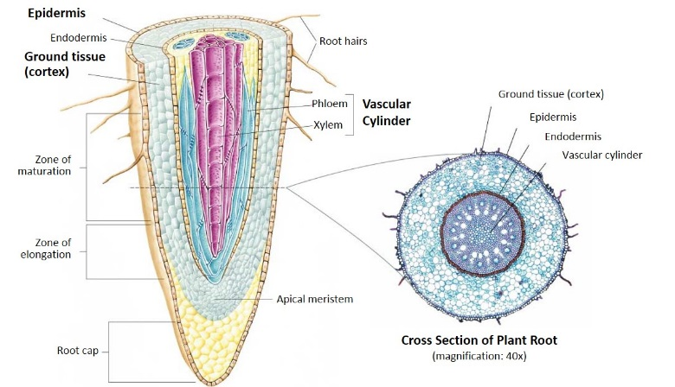
Plant Parts: Roots
Author/Source: Patrick Ryan, Alaska Botanical Garden and Melissa Sikes, Fairbanks Soil and Water Conservation District

Suggested Grade Levels: 2-6th grade

Time: 45 minutes

Teaching Goal: Students will review what plants need to grow and learn about the function of roots. They will discuss various roots they eat and learn about the different parts of a root.

Learning Objectives:
To explore the plant life cycle by focusing on roots and their function for the plant.

Core Ideas:
- Plant Anatomy
- Plant Life Cycles
- Plant Dynamics (circulation and nutrient uptake)
- Recording Scientific Data
- Standardized Science Measurements
- Drawing Conclusions from Experimentation (hands-on, observation, drawing, and note-taking)

Alaska State Science Standards: 2-LS4-1, 3-LS4-4, 4-LS1-1, 5-LS1-1, 5-LS2-1, MS-LS1-1, MS-LS1-2, MS-LS1-4

NGSS Standards: 2-LS2-1, 2-PS1-1, 3-LS1-1, 4-LS1-1, 5-LS1-1, MS-LS1-1, MS-LS1-2

Materials Needed:
- Carrots
- Growing plant (in soil)
- Plastic knife and cutting board
- Ruler
- Root Diagram
- Large bowl of water (1 per group)
- Root Investigation Sheet
- Magnifying lenses
- Newspaper for the desks to catch soil.

Vocabulary:
- Chlorophyll: A green pigment that captures light energy for photosynthesis.

- Circumference: The size of something as given by the distance around it. Ex: the length of the closed curve of a circle.

- Cortex: The outermost layer of a stem or root in a plant.

- Diameter: A straight line going through the center of a circle connecting two points on the circumference.

- Epidermis: A single layer of cells that covers the leaves, flowers, roots and stems of plants. It forms a boundary between the plant and the external environment.

- Evapotranspiration: Process by which water that has been carried through the plant from its roots to its leaves evaporates from the leaves.

- Flowers: The reproductive part of plants. They often have showy petals and fragrances to attract pollinators such as birds, bees, and other insects. Most flowers have four main parts: petals, stamen (anther and filament), pistil (stigma, style, and ovary), and sepals. After flowers are pollinated and fertilized, they produce seeds in the ovary of the flower.

- Fruits: The fleshy substances that usually surround seeds. They protect the seeds and attract animals to eat them. This helps in seed dispersal.

- Leaves: The parts of the plant where photosynthesis usually occurs—where food for the plant is made. The green substance, chlorophyll, captures light energy and uses it to convert water and carbon dioxide into plant food and oxygen.

- Phloem: Transports food from the leaves to the rest of the plant.

- Roots: The part of a plant that grows underground, gets water from the ground, and holds the plant in place,

- Root Hairs: Each of a large number of elongated microscopic outgrowths from the outer layer of cells in a root, absorbing moisture and nutrients from the soil.

- Seeds: Contain plant material that can develop into another plant. This plant material is called an embryo. Seeds are covered with a protective seed coat and have one or two cotyledons. Cotyledons are the food for the baby plant until it can make its own food from light and are often the first embryonic leaves of the plant.

- Stems: Support the upper part of the plant and act as a transport system for nutrients, water, sugar, and starches. Photosynthesis can occur in the stem of some plants such as: cacti, celery, asparagus, and bananas.

- Transpiration: Transpiration is the process by which water evaporates from the leaves, which results in more water being drawn up from the roots.

- Vascular Tissues: Strands of conducting vessels in the stem or leaves of a plant, typically with phloem on the outside and xylem on the inside.

- Xylem: Transports water and solutes from the roots to the leaves.

Background for Teachers: The root is the organ of a plant that typically lies below the surface of the soil. Roots can also be aerial or aerating, that is, growing up above the ground or especially above water. Furthermore, a stem normally occurring below ground is not exceptional either. Therefore, the root is best defined as the non-leaf, non-nodes bearing parts of the plant's body. However, important internal structural differences between stems and roots exist. A root's four major functions are 1) absorption of water and inorganic nutrients, 2) anchoring of the plant body to the ground and supporting it, 3) storage of food and nutrients, 4) vegetative reproduction and competition with other plants. Roots often function in storage of food and nutrients. The roots of most vascular plant species enter into symbiosis with certain fungi to form mycorrhizae, and a large range of other organisms including bacteria also closely associate with roots.

When dissected, the arrangement of the cells in a root is root hair, epidermis, epiblem, cortex, endodermis, pericycle and, lastly, the vascular tissue in the center of a root to transport the water absorbed by the root to other places of the plant

The two main types of roots are taproots and fibrous roots.
- Taproots: the primary root grows long and thick, while the secondary roots stay small. (ex. carrots or turnips)
- Fibrous roots: just secondary roots that grow and branch out. (ex. basil, lettuce, or spinach)

ACTIVITIES
Introduction
Teach or review “What is the LAW for plants?” L.A.W. (light, air, water- best for younger students) and/or PL.A.N.T.S. (place, light, air, nutrients, thirsty, soil-best for older students).

Initial Brainstorm/Learning (15 minutes)
- Discuss how just as people have different jobs in our community, different parts of plants have jobs to help the plant grow. Review the 6 plant parts (Roots, Stems, Leaves, Flowers, Fruits, and Seeds).
- Roots have several jobs to do for the plant. Have students generate a list of the possible jobs the root does and the function of the root. Accept all reasonable answers and write them on the white board.
- Discuss roots we eat (carrots, potatoes, turnips, etc.). Show using a straw how the a root moves water up to parts of the plant. Discuss how the plant does this.
- Upper Grades: Look at the root diagram and talk about the vascular bundles and xylem versus the phloem. Vascular bundles essentially are the network of connections. In humans, that involves arteries, veins and capillaries. In plants, it’s the xylem and phloem. Xylem moves water and minerals up from the roots. Phloem moves sugar (food from photosynthesis), down from the leaves to the rest of the plant.

Hands-On Learning (Taproot) Part 1 (15 minutes)
- Split into groups of 2-3 students/group.
- Pass out carrots, 1 per every 2-3 students.
- Have them, or you can do ahead of time, cut the carrot lengthwise.
- Ask students questions about layers they can see in the dissected carrot?
- Have them compare the layers to those on the diagram.
- Have them draw what they see on the worksheet.

Hands on Learning (Fibrous Roots) Part 2 (15 minutes)
- Show students the growing plants in soil.
- Pass out 1 plant to each group.
- Have them pull the plant out of the pot and rinse the soil of the roots in the bowl of water as best as they can.
- Have them investigate the roots with a magnifying glass and identify the root hairs.
- Have them try to open up the small roots and investigate with the magnifying glass.
- Have them draw what they see on the worksheet.

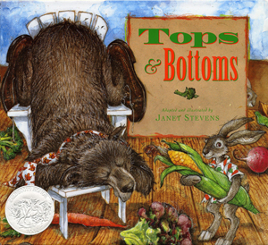
Extensions:
- Read part of Tops and Bottoms by Janet Stevens

- Listen to or sing Banana Slug String Band song “Roots, Stems, Leaves. Flowers, Fruits and Seeds.”

Lyrics to “Roots, Stems, Leaves. Flowers, Fruits and
Seeds.”
Chorus:
Roots, stems, leaves, flowers,
Fruits and seeds
Roots, stems, leaves, flowers,
Fruits and seeds
Roots, stems, leaves, flowers,
Fruits and seeds
Roots, stems, leaves, flowers,
Fruits and seeds
That’s six parts, six parts, six plant parts
that plants and people need.
The roots hold the plant
in the ground.
They gather up the water
that falls around.
And there’s a root inside of me,
because a carrot is a root that I eat.
That’s six parts, six parts, six plant parts
that plants and people need.
A stem is an elevator growing up from
the ground.
The water goes up and the
sugar back down.
And there’s a stem inside of me
because celery is a stem that I eat.
The leaves are the kitchens
where the food is done.
They breath the air and
catch rays form the sun.
And there’s a leaf inside of me
because lettuce is a leaf that I eat.
Chorus…
The flowers are dressed so colorfully.
They hold the pollen and
attract the bees.
And there’s a flower inside of me
because cauliflower is a flower I eat.
The fruit gets ripe, then falls on down.
It holds the seeds and feeds the ground.
And there’s a fruit inside of me
because an apple is a fruit that I eat.
Chorus…
Now you know what this
whole world needs.
It’s roots, stems, leaves, flowers,
fruits and seeds.
There’s six plant parts inside of me
because a garden salad is what I eat.
Chorus…

Assessment:
Assess student worksheets for accuracy, completion, and participation in the activities.

References:
Books:
The Budding Botanist (AIMS Activities Grades 3-6) Investigations with Plants
by Evalyn Hoover, Howard Larimer, Sheryl Mercier, Michael Walsh, Dave Youngs and Beverly Tillman 2009 ISBN: 1-881431-40-1

Plant Plumbing: A Book About Roots and Stems (Growing Things)
by Susan Blackaby 2003 ISBN: 1-4048-0109-X; ISBN: 978-1-4048-0385-5

Tops & Bottoms
by Janet Stevens ISBN: 0-15-292851-0

Websites:
http://mandevillehigh.stpsb.org/teachersites/laura_decker/ap_roots_stems_and_leaves_diagrams.htm

http://www.bbc.co.uk/schools/gcsebitesize/science/add_ocr_gateway/green_world/planttransportrev1.shtml
http://water.usgs.gov/edu/watercycletranspiration.html
https://basicbiology.net/plants/physiology/xylem-phloem/

https://basicbiology.net/plants/physiology/xylem-phloem/

Root Investigation

Name___________________________________________ Date____________

Taproot
Draw the taproot (carrot) here. Diagram the parts of the root.

Fibrous Roots
Draw the fibrous roots here. Diagram the parts of the roots that you can see.

Conclusions:

Root Diagram
from “Plants Structure and Function” by Mervin Parrish https://slideplayer.com/slide/7659799/
